Lab Assignment

Author
Institutional Affiliation
Instructor
Course code
Date of submission

Leaves or stem of a mature plant
Onions
Onion leaves and stems are considered essential additives to a balanced and healthful diet. Onions are monocots with parallel-veined leaves. Besides being used as a food additive by humans, onions are also used in the manufacture of medicines due to its medicinal values that include reducing inflammation, reducing lung tightness in people with asthma, and reducing cholesterol and sugar in the blood.
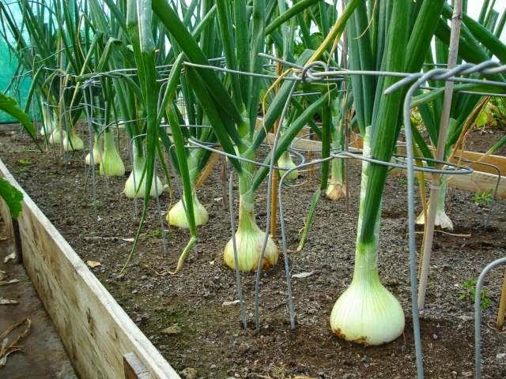
https://www.kpcnews.com/features/life/article_2c63a634-ebe9-534c-93a8-0ba05c27d025.html

Broccoli
Broccoli can be harvested just before flowering to be typically eaten by many humans since the flowers are not considered delicious. The tight-packed green buds of broccoli make essential component of the human diet. Broccoli plants are dicots which are usually picked as green vegetables just before their flowers show.
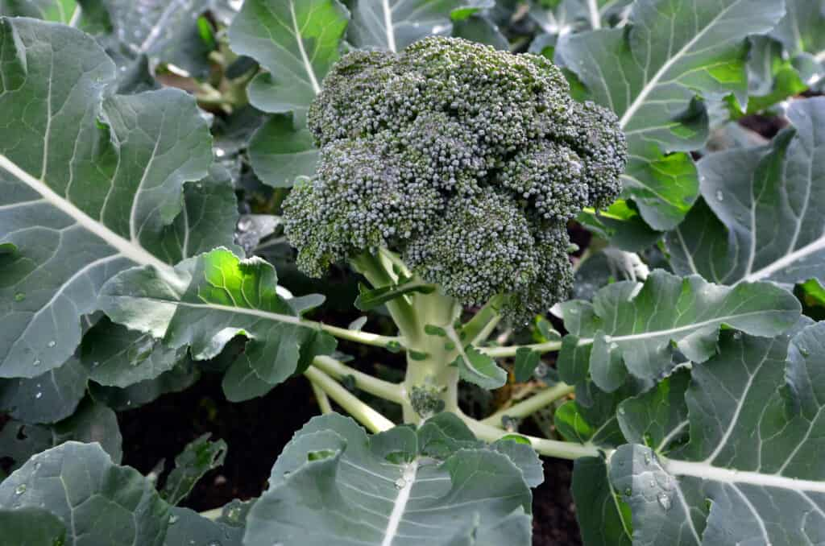
https://harvesttotable.com/how_to_grow_broccoli/

Cotton
Cotton plants are dicot plants. The plant stems have proven to be essential source of wood fuel especially after harvesting the cotton wool from the farm. Similarly, the leaves of the plant are also used to feed animals in some regions with limited supply of Napier.
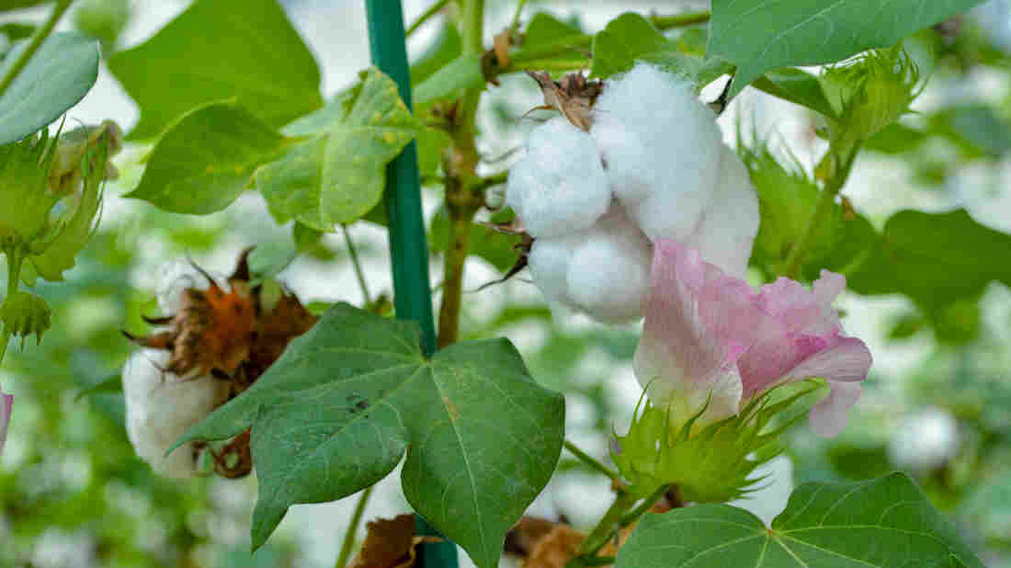
https://www.npr.org/sections/thesalt/2018/10/17/658221327/not-just-for-cows-anymore-new-cottonseed-is-safe-for-people-to-eat

Flowers and pollen of a mature plant
Pyrethrum
Pyrethrum is a dicot plant whose flowers are used in the manufacture of insecticides. The flowers possess insecticidal properties and has been an essential remedy for lice.
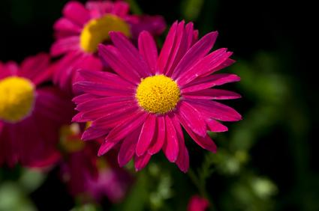
https://garden.lovetoknow.com/wiki/Pyrethrum#:~:text=Pyrethrum%20refers%20to%20several%20flowers,insects%20away%20from%20other%20plants.

California Poppy
California poppy is a dicot plant whose flowers possess medicinal properties. Overtime, the extracts from this plant have been used to relieve menstrual cramps. Also, cats use the flowers to cause vomiting thus eliminating stomach distress.
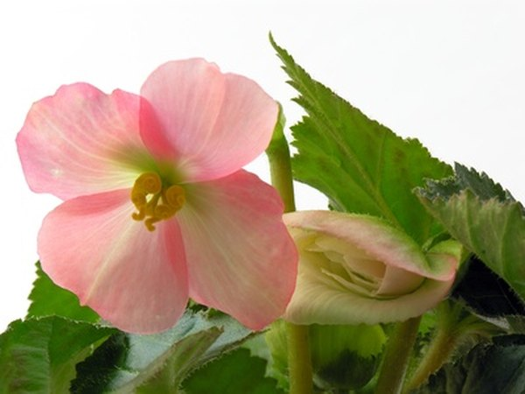
References
https://sciencing.com/importance-of-flowers-in-nature-12000163.html

Brassavola Orchids
Brassavola Orchids are monocots with white or greenish flowers that are exceptionally fragrant. The plant is normally is grown as a house plant to achieve an ornamental purpose.
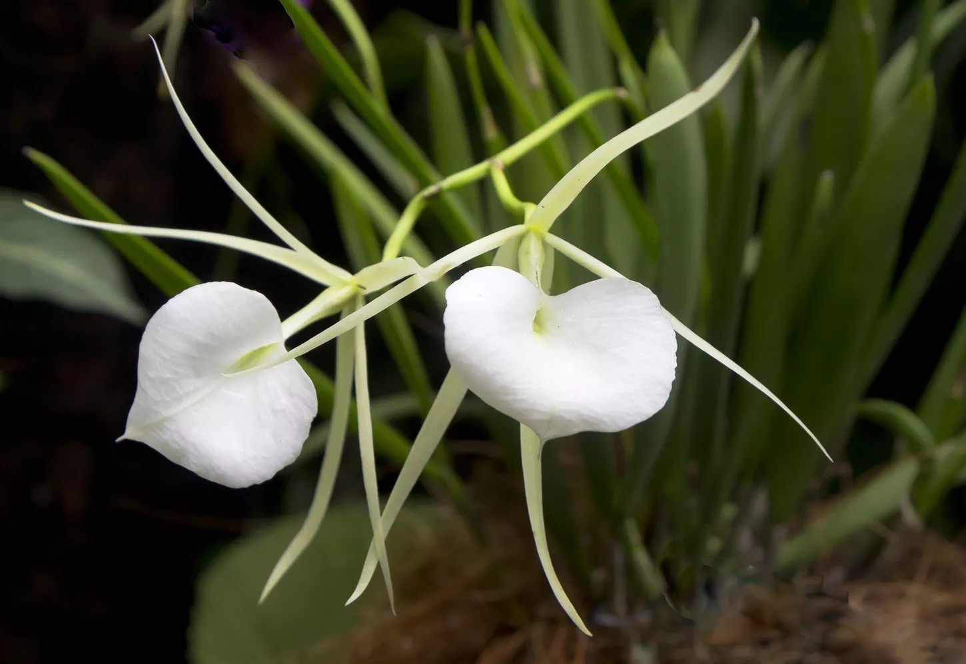
https://www.thespruce.com/orchid-identification-1315976

Seeds or fruits of mature plants
Cotton seeds
Cotton is a dicot plant whose seeds are essential commercially in the manufacture of cooking oils. Additionally, the plant seeds are also used in the manufacture of essential additives used in the manufacture of poultry and livestock feeds.
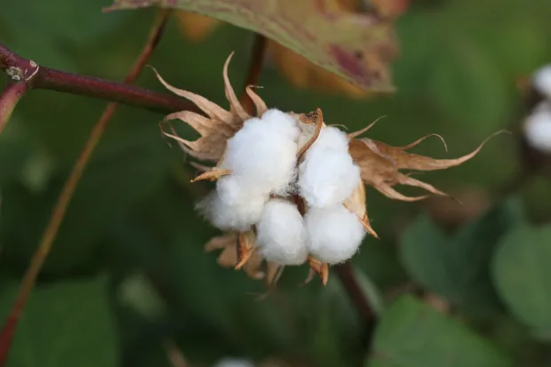
https://owlcation.com/agriculture/cottonseed-oil

Sunflower
Sunflowers are dicots whose seeds are used in the manufacture of consumable sunflower oils. Additionally, sunflower seeds, due to their medicinal properties have proven to be essential in the manufacture of medicines capable of lowering risks of high-blood pressure or heart diseases. The consumption of sunflower seeds is also important in supporting body immunity and boosting the energy levels.
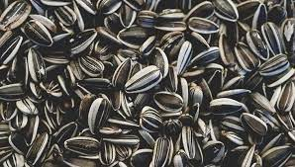
https://www.healthline.com/nutrition/sunflower-seeds

Rice
Rice plant is a monocot plant whose seeds provide humans with essential food source. Originating from the grass species, rice seeds are edible by humans and provides starch.
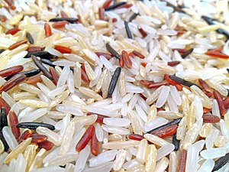
https://en.wikipedia.org/wiki/Rice

